

Year 9 Science
Chemistry Test 1: Atoms

SECTION 1: MULTIPLE CHOICE (1 mark each)
Circle your answer on the multiple choice answer sheet.

- If a substance is made up just one type of atom it is referred to as
- a molecule
- an isotope
- a lattice
- an element

- A compound is best described as
- a substance made of molecules
- a substance made of only one type of atoms
- a substance made of elements which are chemically combined
- a substance made of metals and non-metals

- Which of the following shows the formula of an element?
- C₆H₁₂O₆
- Fe
- MgCl₂
- H₂SO₄

- Which type of particles is not found in the nucleus of an atom?
- proton
- neutron
- electron
- all of the above

- Which of the following is not true about protons?
- They have a mass of 1/12 of the mass of a carbon atom.
- They have a relative mass of 1
- They have a charge of +1
- They always equal the number of neutrons.

- For any isotope, the number of protons + the number of neutrons is equal to
- the atomic number
- the relative atomic weight
- the mass number
- the number of electrons

- An atom has 11 protons, 12 neutrons and 10 electrons it is
- an isotope of magnesium
- an ion of sodium
- an atom of neon
- radioactive

- In a neutral atom, the number of electrons is always
- equal to the number of protons
- equal to the number of neutrons
- equal to the mass number
- equal to the charge

- The Gold Foil experiment (below) was conducted by New Zealand scientist Ernest Rutherford.

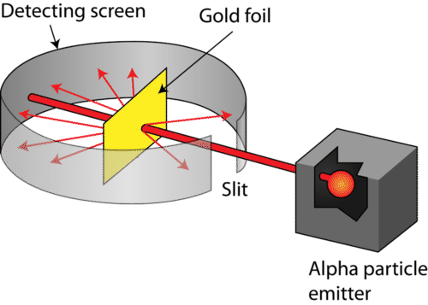
The experiment showed that
- atoms are indivisible
- most of the atom is empty space, with a small positively charged nucleus
- atoms contain both protons and neutrons in their nucleus
- electrons are found in shells depending on how much energy they have

- Ions are atoms (or groups of atoms) that
- have gained or lost electrons.
- are charged.
- are anions or cations.
- all of the above

- Metals are described as lustrous because they
- shine when polished
- can be bent into new shapes
- can be stretched into wires
- conduct both heat and electricity

- The melting and boiling points of metals are best described as
- low
- moderate
- relatively high
- very high

- Which of the following is an alloy?
- iron
- zinc
- magnesium
- steel

- Metalloids act like non-metals in most ways, except that
- they are usually gases at room temperature
- they are able to conduct electricity under certain conditions
- they melt at a higher temperature
- they are brittle

- Acids are
- corrosive
- bitter
- always dangerous
- non-conductors

- Which is the best way to determine if a substance is an acid or base?
- taste it
- test its conductivity
- look at its formula
- test its pH

- Which of the following only contains bases?
- sodium hydroxide, calcium hydroxide, bicarb soda
- sodium hydroxide, water, bicarb soda
- sodium hydroxide, vinegar, hydrochloric acid
- tap water, lemon juice, vinegar

- What colour does litmus turn in acid?
- red
- green
- blue
- purple

- Isotopes are
- atoms with the same number of protons but different number of neutrons
- atoms with the same atomic number but different mass number
- ‘versions’ of the same element
- all of the above

- The type of radiation with the biggest mass, the lowest speed and the lowest penetration (distance travelled through air) is
- alpha
- beta
- gamma
- neutron

SECTION 2: WRITTEN
Write all answers in the spaces provided. If you need more space, ask for some lined paper

- Complete the table about subatomic particles (7 marks)

 | protons | neutrons
Relative mass |  |  | 1/1800
Charge | +1
Location |  | nucleus

- Label the following as elements or compounds (4 marks)

- carbon (C) ____________________________

- water (H₂O) ____________________________

- Sulfur dioxide (SO₂) ____________________________

- Oxygen (O₂) ____________________________

- Complete the table for the following atom: (6 marks)
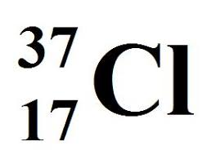
element name
atomic number
number of protons
number of neutrons
number of electrons
metal or non-metal

- List 5 properties of metals (5 marks)

- ______________________________
- ______________________________
- ______________________________
- ______________________________
- ______________________________

- The following contains a list of properties and examples.

Classify each as acid, base or neutral (Tick any that apply)
(6 marks)

 | acid | base | neutral
corrosive
pH 7
sour
bitter
conduct electricity
turn indicator or litmus paper blue
vinegar
soap
distilled water
Salt

End of test (out of 48)

